Urban Game Measurement Key

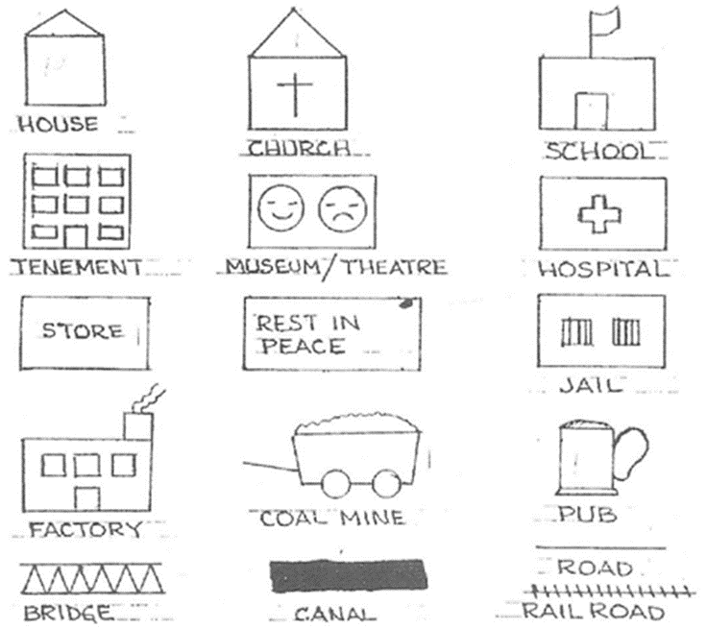

Measurements
Each element of your city should be measured using a ruler. No building should be larger than 1”.

Houses and churches: ¼”x ¼” (you can add a roof).

Large (rich) houses: ½ ” x ½ ”

Tenements: 1” x 1”.

Specialty building (school, store, hospital, coal mine, etc…): 1” x ½”.

Factories: 1” x 1”

Bridge, Canal, Railroad: ¼” wide

