T-Shirt Assembly Line - Simulation Directions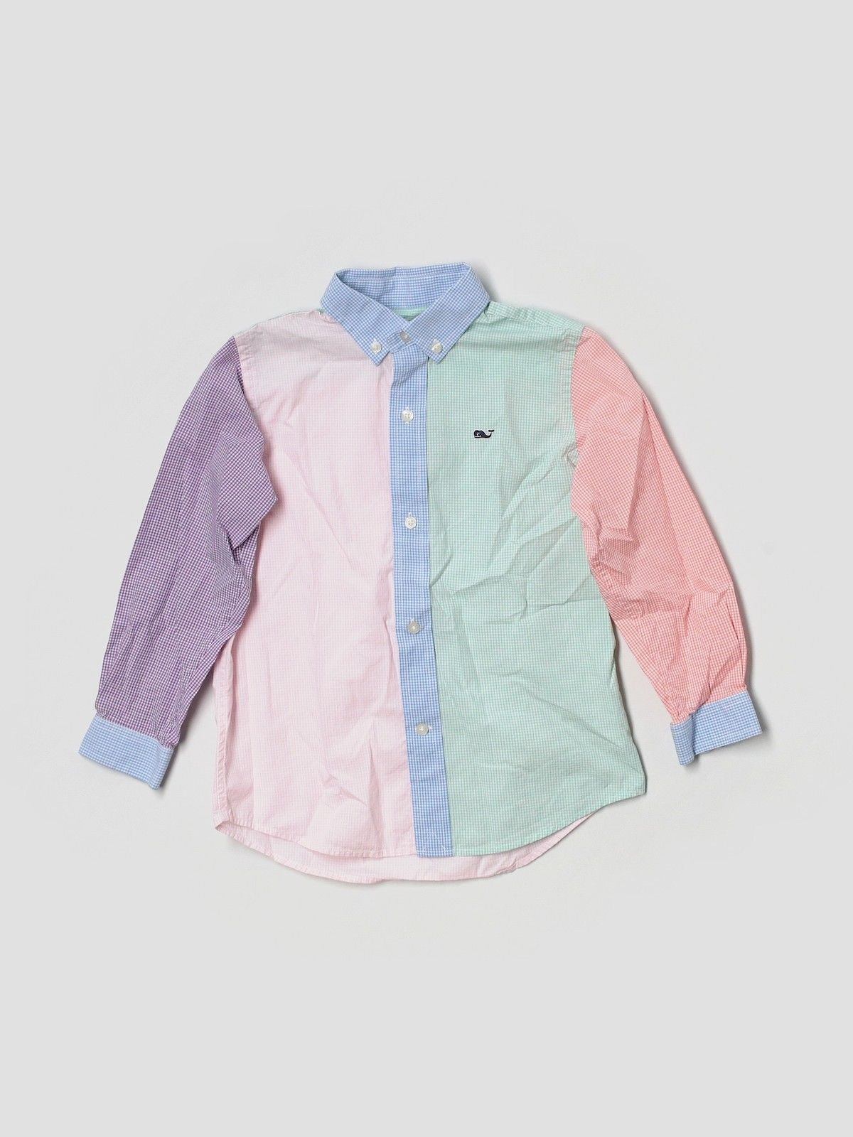

- Draw torso
- Draw collar
- Draw left sleeve
- Draw right sleeve
- Draw left sleeve cuff
- Draw right sleeve cuff
- Draw 2 collar buttons
- Draw 5 shirt buttons
- Color left arm purple
- Color left torso pink
- Color center blue
- Color right torso green
- Color right sleeve red
- Color sleeve cuffs blue
- Draw Whale Logo
- Color Whale logo

