Sources on Nationalism
Source 1: Jewish Nationalism
We are a people — one people.
We have sincerely tried everywhere to merge with the national communities in which we live, seeking only to preserve the faith of our fathers. It is not permitted us… In our native lands where we have lived for centuries we are still decried as aliens, often by men whose ancestors had not yet come at a time when Jewish sighs had long been heard in the country. . . Oppression and persecution cannot exterminate us. No nation on earth has endured such struggles and sufferings as we have.
Palestine is our unforgettable historic homeland. . . Let me repeat once more my opening words: The Jews who will it shall achieve their State. We shall live at last as free men on our own soil, and in our own homes peacefully die.
-Theodor Herzl
1. Why are many Jews dissatisfied with their situation in the countries they live? What is Herzl’s recommendation?

Source 2: Wars Fought in the 19th Century

- Napoleonic Wars 1803-1815: France’s various conquests in Europe eventually stopped by Great Britain, Austria, and Prussia (about 3,000,000 deaths)
- Russo-Turkic War 1828-1829: France and Great Britain assisted Russia against the Ottoman Empire (about 150,000 deaths)
- First Carlist War 1832-1840: Uprising in Spain put down by France and Great Britain (about 100,000 deaths)
- Crimean War 1854-1856: France and Great Britain assisted the Ottoman Empire against Russia (about 250,000 deaths)

- What is the overall trend in the changes in casualties in the wars? Why did the change you identified occur?

Source 3: Italian Nationalism
“A Country is not a mere territory; the particular territory is only its foundation. The Country is the idea which rises upon that foundation; it is the sentiment of love, the sense of fellowship which binds together all the sons of that territory.”
O my Brothers! love your Country. Our Country is our home, the home which God has given us, placing therein a numerous family which we love and are loved by…”
― Giuseppe Mazzini
- What feelings does Mazzini use to describe a country? How could this way of looking at your country be both helpful and potentially harmful?

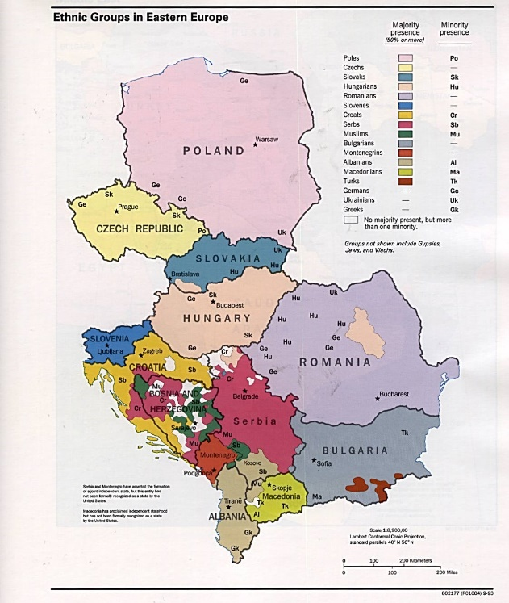
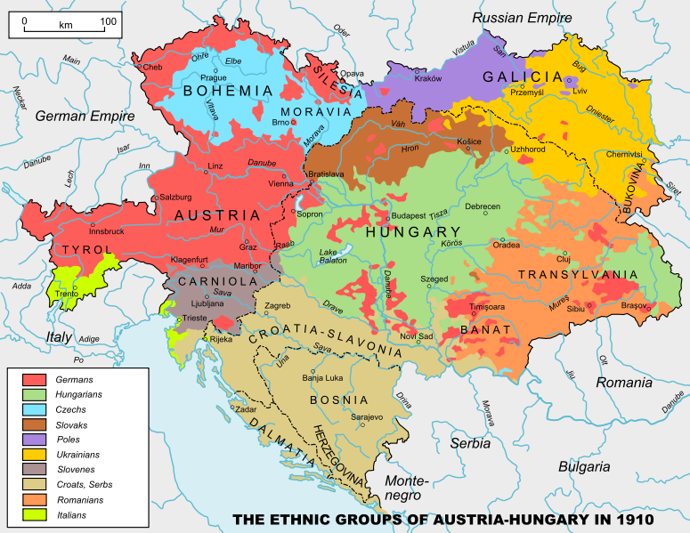
Source 4: Comparing maps of nationalities in Eastern Europe in 1910 and present.

- What are the changes you see in the maps of the regions in Eastern Europe? Why do you believe the changes you identified occurred?

Source 5: Revolutions of 1848
The Revolutions of 1848, while widespread, were short-lived events. Their aims varied from country to country but they had the common goals of advancing nationalist goals and taking power from the ruling aristocracies to create governments that represented more of the people. Though most of these revolutions failed to reach these goals, they were by no means insignificant. The modernization of ideals, the rise of nationalism, the shifts in political ideologies, and the rise of the popular will outlasted the revolutions themselves, and are what make them so significant to European history.
-D.H. Darwin
5. Evaluate the success or failure of the Revolutions of 1848. What are their lasting legacies?

