Napoleon Bonaparte – Document Based Question
With each document, assess the validity of the following statement:

Napoleon Bonaparte stabilized and united French society, yet supported the ideals of the French Revolution

Document A
...Undoubtedly the greatest obstacles have been overcome; but you still have battles to fight, cities to capture, rivers to cross. Is there one among you whose courage is abating?...No,...All of you are consumed with a desire to extend the glory of the French people; all of you long to humiliate those arrogant kings who dare to contemplate placing us in fetters; all of you desire to dictate a glorious peace, one which will indemnify the Patire for the immense sacrifices it has made; all of you wish to be able to say with pride as you return to your villages, "I was with the victorious army of Italy!"
Friends, I promise you this conquest; but there is one condition you must swear to fulfill--to respect the people whom you liberate, to repress the horrible pillaging committed by the scoundrels incited by our enemies. Otherwise you would not be the liberators of the people; you would be their scourge; ... Plunders will be shot without mercy; already, several have been...Peoples of Italy, the French army comes to break your chains; the French people is the friend of all peoples; approach it with confidence; your property, your religion, and your customs will be respected. We are waging war as generous enemies, and we wish only to crush the tyrants who enslave you.- Napoleon's speech to his troops, 1796

Document B
Napoleon Crossing the Alps by Jacques Louis David, 1800

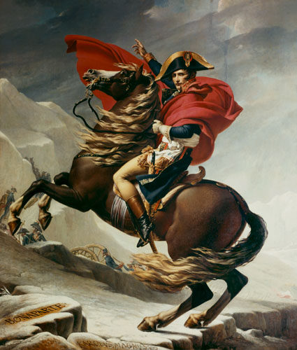
Document C
My power proceeds from my reputation, and my reputation from the victories I have won. My power would fail if I were not to support it with more glory and more victories. Conquest has made me what I am; only conquest can maintain me. Friendship is only a word; I love nobody; no, not even my brothers. -- Napoleon's dairy entry on December 30, 1802

Document D
Q: What are the duties of Christians with respect to the princes who govern them, and what in particular are our duties towards Napoleon I, our Emperor?
A: Christians owe to the princes who govern them, and we owe in particular to Napoleon I, our Emperor, love, respect, obedience, fidelity, military service and the tributes laid for the preservation and defense of the Empire and of his throne; we also owe to him fervent prayers for his safety and the spiritual and temporal prosperity of the state...
Q: Are there not particular reasons which ought to attach us more strongly to Napoleon I, our Emperor?
A: Yes; for it is he whom God has raised up under difficult circumstances to re-establish the public worship of the holy religion of our fathers and to be the protector of it. He has restored and preserved public order by his profound and active wisdom; he defends the state by his powerful arm; he has become the anointed of the Lord through the consecration which he received from the sovereign pontiff, head of the universal church.
Q: What ought to be thought of those who may be lacking in their duty towards our Emperor?
A: According to the apostle Saint Paul, they would be resisting the order established by God himself and would render themselves worthy of eternal damnation. -- Napoleonic Catechism, 1806

Document E
I am concerned for the happiness of your subjects, not only as it affects your reputation, and my own, but also for its influence on the whole European situation...Your throne will never be firmly established except upon the trust and affection of the common people. What German opinion impatiently demands is that men of no rank, but of marked ability, shall have an equal claim upon your favor and your employment, and that every trace of serfdom, or of a feudal hierarchy between the sovereign and the lowest class of his subjects, shall be done away. The benefits of the Code Napoleon, public trial, and the introduction of juries, will be the leading features of your government. And to tell you the truth...I want your subjects to enjoy a higher degree of liberty, equality, and prosperity hitherto unknown to the German people. I want this liberal regime to produce, one way or another, changes which will be of the utmost benefit to the system of the Confederation, and to strengthen your monarchy. Such a method of government will be a strong barrier between you and Prussia than the Elbe [River], the fortress, and the protection of France. What people will want to return to under the arbitrary Prussian rule, once it has tasted the benefits of a wise and liberal administration? In Germany, as in France, Italy, and Spain, people long for equality and liberalism. - Letter written to Jerome Napoleon, King of Westphalia, by Napoleon on November 15, 1807

Document F
To date from the publication of the present decree, feudal rights are abolished in Spain.
All personal obligations, all exclusive fishing rights and other rights of similar nature on the coast or on the rivers and streams, all feudal monopolies of ovens, mills and inns are suppressed. It shall be free to everyone who shall conform to the laws to develop his industry without restraint.
Napoleon's Imperial Decree at Madrid, December 4, 1808

Document G
Coronation of Napoleon as Emperor of France
