Israeli-Palestinian Conflict Negotiation
In this activity, students will play the role of either the Palestinians or the Israelis in order to negotiate a peaceful solution to this decades-old conflict.
- Students will first view the following animated videos: http://www.youtube.com/watch?v=uq6tDmLNPjU, http://www.youtube.com/watch?v=Y58njT2oXfE.
Have the students take notes on what they think are the top three important issues for the Israelis and the top three important issues for the Palestinians.
- Lead the class in a discussion about what students found are the ways the videos agreed and disagreed with each other about the causes of the conflict in the region.
- Break students into groups of four with two students each being assigned the position of being either Israelis or Palestinians.
- If you wish the students to do further research on the topic, you can have them look at the information on the following pages:
Overview: http://israelipalestinian.procon.org/view.resource.php?resourceID=000631
Points of Conflict: http://israelipalestinian.procon.org/view.resource.php?resourceID=000632
- Have students look at the summary of points of conflict on the following page. They are to work with their partner to highlight their positions and prepare for their negotiation. Have them keep in mind that not all Israelis or Palestinians agree with people even on their own side so therefore they may not want to choose every bullet in their column to defend. Students should scale each issue in order of importance so to prepare what positions they are willing to compromise.
- Put the two pairs of Israelis and Palestinians together. They are to use the third sheet and the maps to create their compromises and negotiate their solutions. Be sure to emphasize to them not to give in too easily as these are deeply important issues them but also give them a timeframe to reach a compromise. The teacher can play the role of arbiter to force agreements if they come to an impasse.
- Have students reflect on the final questions in a paragraph. Debrief this experience for them so they can apply their newly acquired learning to the modern world.

Israeli Palestinian Conflict: Major Positions
One or Two State Solution: Should Israel and Palestine be independent countries? How important? __/5
Israeli Positions:  - One state: Israel in its entirety is the historic and religious homeland of the Jewish people so it should not be shared with the Palestinians. Arabs have a history of attacking Israel so it should be defended.  - or Two state: The only way to peace and international approval is through creating two independent countries. |  | Palestinian Positions:  - One state: Palestine was controlled by the Islamic Arab people for over a thousand years. We do not recognize Israel’s right to exist and will continue to fight regain our homeland.  - or Two state: The only way to peace and international approval is through creating two independent countries.
Jerusalem: How should control the city and its holy sites? How important? __/5
Israeli Positions:  - The city of Jerusalem has been the holy city for the Jewish people for over 2500 years. In the diaspora it has been a symbol of home promised by God. It contains the Western Wall and many other holy sites.  - It is the capital of sovereign Israel and cannot be controlled by the Palestinians or any international agency. |  | Palestinian Positions:  - For the Muslims, Jerusalem is the location that Muhammad made his final ascent into heaven and one of the three holy cities of Islam. It contains the holy mosque The Dome of the Rock.  - Muslims have controlled the city for nearly 1500 years and continue to be a significant portion of the population.
The Palestinian Right of Return: Many Palestinians lost their homes, fields, and property when the Israelis took them in the first war. They wish for the right to reclaim them. How important? __/5
Israeli Positions:  - Most of the refugees were created when the Arabs first attacked Israel  - Jews were kicked out of Arab countries so it fair that Palestinians get kicked out of Israel  - The Israelis have created a homeland for over 60 years and the homes the Palestinians used to have no longer exist. |  | Palestinian Positions:  - The Palestinians want to regain their homes that were taken away from the Jews who came in only very recently  - The Palestinians have no homeland in other Arab states and many have had to live in refugee camps for the last 60 years  - The Palestinians demand the right to their historical homes and will fight if necessary
Israeli Settlements in the West Bank: Israelis have been building settlements for Jews in Palestinian territories with walls to defend them How important? __/5
Israeli Positions:  - Israelis have a right to all the land not half according to old international agreements  - Israel needs to create areas of defense in case the Arabs try to attack again (which they have done three times already)  - The settlements have roads, infrastructure and development that the Palestinians have not been able to do. |  | Palestinian Positions:  - The settlements prove that the Israelis are not serious about peace. It shows that Israel just wants to slowly take over the whole area for itself  - The settlements have put up walls and checkpoints so Palestinians are prisoners in their own homeland  - Good land is being taken away from the Palestinians and making them poor while Israelis prosper
Other issues you may address: Israel’s use of its military, terrorist attacks from Palestinian organizations like Hamas and Hezbollah, the border fence, Israel’s relationship with other Arab countries
Point of Conflict | Negotiated Agreement
1. One-state or two-state solution? How will you divide these states?
2. Who will control Jerusalem?
3. What about Palestinian’s Right of Return?
4. What about the Israeli Settlements in Palestinian territories?
5. Other issues and agreements

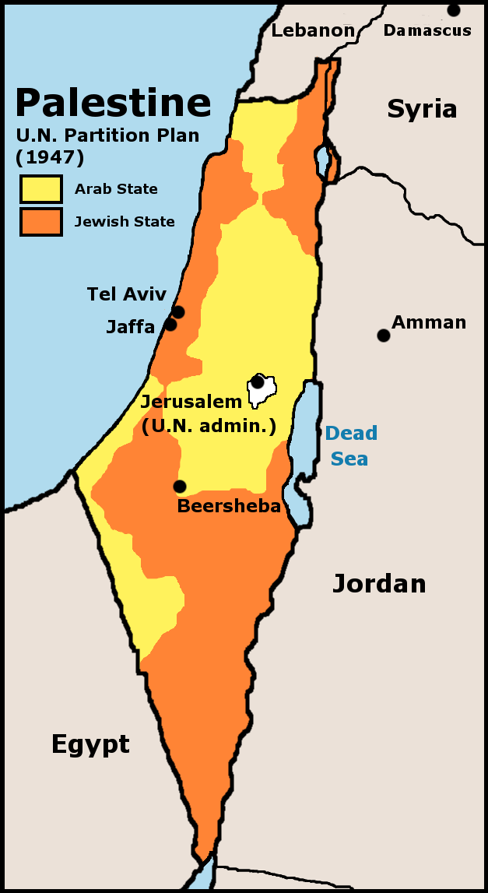
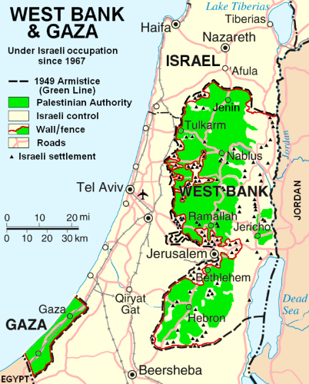
Reflection (in a paragraph on a separate piece of paper): Why don’t you think that the Israelis and Palestinians have come to an agreement? What do you think will happen in the future in this region? What can America do to help?

