Kashmir: The Most Dangerous Place in the World
Kashmir is lush valley nestled beneath the Himalayan Mountains. Once considered a beautiful place for tourists, former President Bill Clinton called it “The most dangerous place in the world.”
Causes of the Dispute
In 1947, India gained its independence from Great Britain but was divided between India and Pakistan. India was dominated by Hindus and Pakistan was designed to be a Muslim state. As part of the Partition of India, the smaller states were allowed to choose whether to be a part of India or Pakistan. This was not a smooth process with many people of minority religions migrating to the other country and violence erupted in many places. The ruler of the Kashmir region was Hindu but most of his people were Muslim. He could not decide which side to join so he delayed joining either in hopes of keeping his province independent. With the region in flux, Pakistani tribesman invaded and began a revolution. The ruler of Kashmir finally did agree to join India but the fighting had already began.
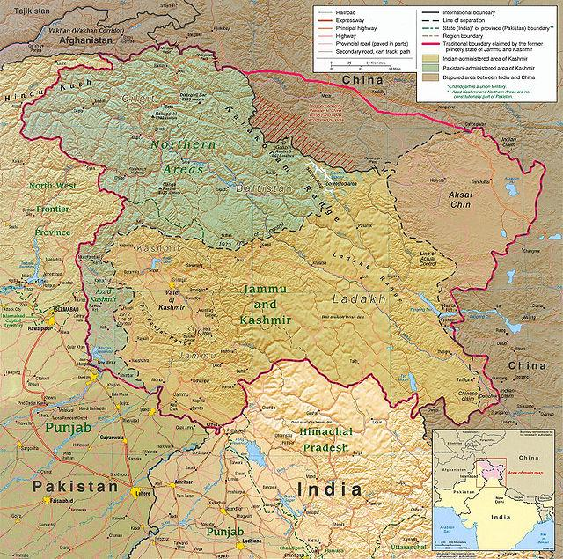
Conflicts over Kashmir
The first conflict was in 1947 with the Indian army fighting against Pakistan-supported militants. After a year of fighting, they agreed to a cease fire with both sides controlling about half the region. The United Nations tried to convince each side to withdraw their armies so that the region could vote but both sides refused to withdraw and India backed away from the agreement to hold a vote.
In 1962, India fought a war with China in which it was defeated. China claimed some parts of this region as a result though India does not recognize China’s right to those regions.
In 1965 and 1971, India and Pakistan resumed fighting. One of the results of the 1971 war was Pakistan surrendering East Pakistan which then became Bangladesh. The issue of Kashmir remained unresolved.
Current Situation
There continues to be sporadic fighting along the effective border between Indian and Pakistani soldiers in Kashmir. Islamic militants have waged an insurgency against India both in Kashmir and have committed terrorism in other parts of India. India on the other hand have committed human rights violations, including over two thousand people found in mass graves, with their abuse of the local population in an attempt to gain control. This situation is especially volatile with both India and Pakistan gaining nuclear weapons in the late 1990s. Another great war could have devastating consequences.

Debate: Students should be divided into groups of 2-4, assigned one side and debate about the fate of Kashmir

Pakistan Perspective
- The majority of the people of Kashmir are Muslim so should be a part of Pakistan
- Kashmir is of cultural, historical, and strategic importance to Pakistan
- It was promised over 50 years ago that the people could vote on whether to choose to go to India or Pakistan and they should do so now
- Pakistan is only providing moral and diplomatic support to the local freedom fighters in Kashmir
- India is the aggressor as seen in their treatment of the local population
Indian Perspective
- Kashmir legally became a part of India in 1947 and was only disrupted by the actions of rebels
- There are hundreds of millions of Muslims that leave peacefully in other parts of India
- A public vote is not to be trusted in the current situation, elections in the Indian democracy is enough to determine the will of the people
- The main problem in Kashmir is terrorism sponsored by Pakistan
- There are minimal human rights violations in Kashmir, the Indian army is just trying to maintain order and to fight terrorism
Notes:

