Comparing Leaders in the Middle Ages
Leader/ Empire | Military accomplishments | Religious contributions | System of Laws/Government | Long-term Legacy
Pope Urban II
(Catholic Church)
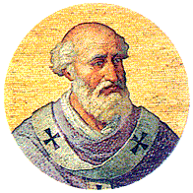
Justinian
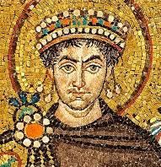
Charlemagne
