BUSHIDO: THE WAY OF THE WARRIOR
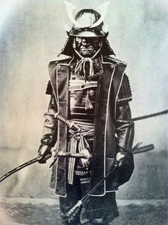
DOCUMENT A

The samurai had an unwritten code of behavior that became known as bushido or, “the way of the warrior.” The Samurai code emphasized loyalty and family values. It placed great value on courage, honor, and self-discipline. Samurai’s put the needs of others in front their own. Capture or surrender was dishonorable.

DOCUMENT B- Seppuku

Rather than fall into enemy hands, samurai commonly committed suicide. The act was performed by stabbing a knife into the left side of the abdomen, drawing across to the right, and giving a final upward twist to the chest. Samurai committed suicide in this fashion not only to avoid capture, but to make up for any unworthy behavior.

DOCUMENT C- The Code of Bushido

“The business of the samurai consists in reflecting on his own station in life, in discharging loyal service to his master if he has one, in deepening is fidelity (faithfulness) in association with friends, and with the due consideration of his own personal position in devoting himself to duty above all.”
-Yamaga Soko (1622-1685)

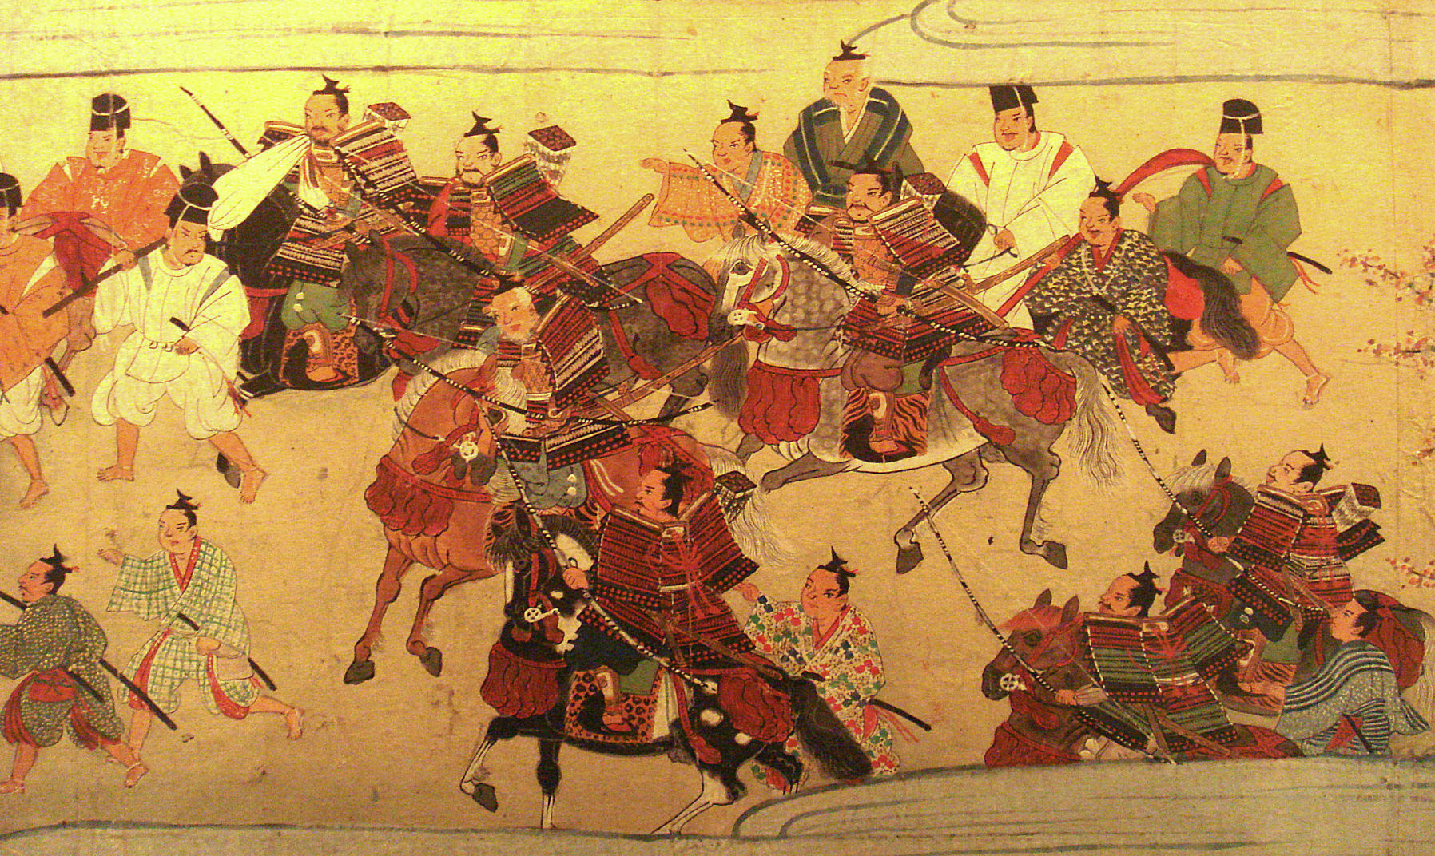
“The way of the warrior (bushido) is to find a way to die. If a choice is given between life and death, the samurai must choose death. There is no more meaning beyond this. Make up your mind and follow the course. Someone may say, ‘you die in vain if you do not accomplish what you set out to do.’

“If the samurai misses his objectives and continues to live, he must be seen as a coward. If he misses his objectives and chooses death…this must be a noble act. It is of utmost importance for bushido. Day and night, if you make an effort to think of death and at a moment’s notice, you and the bushido will become one. In this way, throughout your life, you can perform your duties for your master.”

- Hagakure by Yamato Tsunetomo, 1716

